**East Sussex Highways, Balfour Beatty**

**link: https://live.eastsussexhighways.com/highway-schemes/alfriston-highway-works**

**Alfriston - Highway works**

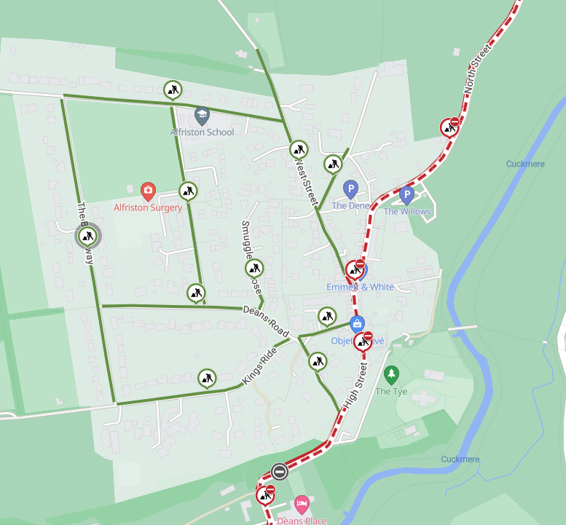

Map of works area

East Sussex County Council is working in partnership with Balfour Beatty Living Places, Wealden District Council, and Alfriston Parish Council to lower speed limits in Alfriston and change the waiting restrictions on C39 High Street. These changes follow the consultation held during August and September 2024.

**When do the works start?**

Work will start on **Tuesday 22nd April** and continue until **Monday 28th April 2025**. Any changes to the dates or times will be communicated via advanced warning signs on-site.

**What are we doing?**

The work includes, updating road signage, refreshing road markings, and adding buff coloured high-friction surfacing (HFS) to raise driver awareness of the change in environment and lower the speed limit.

On completion, the following changes will be in effect:

* Village-wide 20mph speed limit
* 30mph buffer limits on the north and southbound approaches
* Adjustment of the 40mph speed limit extent to the south of the village
* No waiting at any time outside the Star Public House on the High Street to improve traffic flow

**How will this impact highway users?**

For safety, North Street, Waterloo Square, High Street, and Whiteway will be closed while works are in progress. These closures will occur between 8pm and 6am to minimise disruption, with any noisy works being completed before 11pm. A diversion route will be in place via the A27, A26, and A259, and vice versa. Access within the village will be maintained for residents – please approach the closure point. There will be no access for through traffic.

We will be also working on Deans Road, Kings Ride, Sloe Lane, Smugglers Close, Star Lane, The Broadway, Weavers Lane, North Road, The Furlongs, and West Street. Work on these roads, due to the close proximity to Alfriston School, will be restricted to between 9.30am and 3pm.

**Information for residents and businesses**

**Parking:** We will put out ‘no parking’ signs and cones on the site to advise where parking is restricted. Please avoid parking in these locations as it will delay our works.

**Weather:** All of these works are subject to favourable weather conditions, for example heavy rain may affect the progress of the works.

Properties close to the carriageway may experience a temporary disturbance as this can be a noisy process and those properties may experience flashing lights and reversing sirens.

**Permit References -**

**EA005IM-0020-G-01**

**EA005IM-0020-N-01**

**EA005IM-0020-H-01**

**EA005IM-0020-L-01**

**EA005IM-0020-K-01**

**EA005IM-0020-E-01**

**EA005IM-0020-I-01**

**EA005IM-0020-J-01**

**EA005IM-0020-M-01**

**EA005IM-0020-F-01**

**EA005IM-0020-A-02**

**EA005EA005IM-0020-D-02**

**EA005IM-0020-B-02**

**EA005IM-0020-C-02**

We would like to take this opportunity to apologise in advance for any inconvenience or disruption this work may cause, however this forms part of our continuing improvement for the East Sussex highway network. Should you have any concerns regarding these works, you can contact us at eshcomms@balfourbeatty.com.

Please let us know how we did by leaving feedback. Please note you will be redirected to the East Sussex County Council consultation website.

[Feedback Form](https://consultation.eastsussex.gov.uk/economy-transport-environment/copy-of-east-sussex-highways-scheme-feedback)