ALFRISTON PARISH COUNCIL

**CLERK TO THE COUNCIL** Alfriston War Memorial Hall,

Mrs Suzanna Dry Old School House, The Tye,

Alfriston,East Sussex, BN26 5TL

Telephone – 07936 904 743

Email – [clerk@alfristonparishcouncil.org.uk](mailto:clerk@alfristonparishcouncil.org.uk) 11th March 2025

All members of the Parish Council are summoned to a meeting of Alfriston Parish Council to be held in the Alfriston War Memorial Hall on **Monday 17th March 2025 at 7.15pm.**

*Please note that a digital sound recording is made of all meetings of Alfriston Parish Council including Public Questions sessions. The recording is not for publication and used only to aid accurate minute taking.*

S.C. Dry

Mrs Suzanna Dry - Clerk

**AGENDA**

**210. Chairman’s Welcome**

**211. Public Questions**

**212. Apologies for absence**

**213. Update from MP**

To agree date for MP James MacCleary’s ‘Meet & Greet’ session in Alfriston. (**Appendix A**)

**214. Update from Cllr Stephen Shing – East Sussex County Council**

**215. Update from Cllr David Greaves - Wealden District Council**

**216. Declaration of interest**

**217. Minutes**

To agree as a true record the minutes of the APC monthly meeting held on 17th February 2025.

**218. Finance**

To approve the Statement of Finances for March 2025. (**Appendix B**)

**219. Annual Parish Assembly – April 2025**

To decide a date for the meeting and speakers to be invited.

**220. Coffeehouse Conversations**

To decide on date and topic for next one.

**221. Report on Highways & Twittens – Cllr Vacancy**

CityFibre – information received regarding project Gigabit. (**Appendix C**)

The Willows Car Park – Increase in Charges from WDC, awaiting details.

**222. Report on Allotments & Recreation Ground – Cllr Daw**

- Allotment Deposits Jan 2026

**223. Report on Public Transport – Cllr Harris**

**224. Report on Environment & Countryside – Cllr Harris**

**225. Report on Strategic Planning – Cllr Parkinson** . (**Appendix D** )

Update on Emergency Plan and Traffic Calming Measures

**226. Report on Tye – Cllr Spring.**

**227. Report from Planning Committee – Cllr Watkins**

227.1 Applications considered by APC Planning Committee since last meeting:

**Ref. No: SDNP/25/00176/TCA -** 1 High Street, Alfriston, BN26 5SZ. No Objection

Trimming of Yew Tree.

**Alfriston Court, Sloe Lane** - site marked for possible future development under SDNPA Local Plan

Consultation. No objection, but APC asked SDNPA to take into consideration access to the site is

on a very narrow lane.

227.2 Applications notified or awaiting decision from SDNPA

**Ref.No: SDNP/24/04771/LIS -** 7 West St, Alfriston, BN26 5UX. Approved.

Internal & external alterations.

227.3 Enforcement updates from SDNPA - None

**228. Reports from Outside Bodies**

228.1 Heartstart

228.2 Alfriston Emergency Group

228.3 Flood Forum

228.4 Neighbourhood Watch

228.5 Twinning Committee (**Appendix E** )

228.6 St Andrew’s Church

228.7 Clergy House

228.8 Alfriston War Memorial Hall

228.9 Speedwatch

228.10 Events

**229. Correspondence to The Clerk – Asking for permission from the council.**

Wedding Photos on The Glebe - 12th April - To ratify APC’s decision to allow request. (**Appendix F** ).

Wedding Social Space on The Glebe – 27th September. Permission requested. (**Appendix F)**

Wedding A boards on The Tye - 29th March. Awaiting details.

**230. Public Questions**

**231. Councillor Vacancy**

231.1 To receive introduction from applicants for co-option from Rebecca Embry and Nigel Baelz.

Application Forms attached (**Appendix G** ).

231.2 To resolve that Agenda Item No. 231 is to be discussed in confidence, and the press and

public be excluded in accordance with the provisions of Section 1(2) of the Public Bodies

(Admission to Meetings) Act 1960, in view of the business to be discussed.

231.3. To Discuss and Decide on Co-Option of new Councillor.

Cllrs will retire to the Committee Room for discussion.

231.4. Decision on Co-Option to be announced to the meeting.

**232. Date of next meeting –** to be held **on Monday 28th April 2025** in the AWMH at 7:15pm.

Please see Appendices attached below and\or on the website.

**Appendix A - Correspondence from MP**



**Appendix B - March Finance Report**



**Appendix C - Letter from CityFibre**



**Appendix D - Report on Strategic Planning by Cllr Parkinson**



**Appendix E - Report from Twinning Association**



**Appendix F - Permission Request from APC**





**Appendix G - Applications for Councillor Vacancy**

**ALFRISTON PARISH COUNCIL**

**Alfriston Parish Council Co-Option Application Form**

|  |
| --- |
| **Name:** Rebecca Embry |
| **Address:**  Alfriston (full address redacted) |
| **Telephone Number:** Redacted |
| **E-mail address:** Redacted |
| **Are you 18yrs old or over?** Yes |

|  |
| --- |
| **Please detail reasons you wish to be a Councillor ?**  **(Where necessary continue on a separate sheet)** |
| As someone who has known Alfriston all my life, I have a deep rooted love and passion for the village, and it’s many charms. I would like to begin with a brief history about my years spent here, as I feel it is pertinent to my application, and my suitability as a councillor in terms of how well I know and understand it.  My grandparents moved to the village in 1968, and I, along with my mother and sister, came to live with them in 1989 when I was 4 years old. I grew up in the village, and completed my primary education at Alfriston CP School. I attended St Andrews Church, and gave readings under the guidance of the Reverend Fox Wilson, and assisted with preparations such as Christingle.  My sister and I took money on the door for the Horticultural Society Annual Flower Shows, as well as exhibiting (heavily assisted by my Grandparents who were avid gardeners!). For a number of years, our garden was one of the Alfriston Open Gardens raising money for the NSPCC.  As children we were part of the Alfriston Players. I learned to ride at the stables situated on what is now Smugglers Close, spending many happy hours on the Downs. I had tennis lessons at Pleasant Rise Farm when the Tennis Club was in operation, and piano lessons with a teacher in the village. I spent a large part of my childhood and teenage years walking our family dogs in the local area, something I have continued to do as an adult, now with my own cocker spaniel.  After primary school I went to the local Community College in Seaford for my GSCEs and A-Level qualifications, before moving to complete my 2:1 graduate degree in Politics & Sociology at the University of Bristol. Following graduation I returned to Alfriston for a year, working in Brighton before moving up to London where I worked for nearly 20 years in Finance, firstly at HSBC Investment Bank, and then at Ashmore, a specialist Emerging Market investment manager.  Throughout these years, even though I was not residing in the village, Alfriston has always remained home, with me regularly visiting my family over weekends, and spending every Christmas and Easter in the village.  At the age of 40 my husband and I decided to give up London life, and return to our beloved Alfriston, which is where we got married in 2019 in St Andrew’s Church.  Now that I have returned to Alfriston, I would really like to give something back to the place that I have been lucky enough to call home. I feel I have a unique perspective of the village, as I have been both a resident and lived away from Alfriston, seeing the various changes and constants throughout the years. I am keen to assist in preserving its unique magic, whilst also embracing change when it is a positive enhancement.  My career in Finance, which included working as a people manager across continents, has given me many skills and attributes that I feel would make me an excellent councillor, both in terms of serving the residents, and also working well with my fellow councillors.  I am articulate and an excellent communicator, understanding the importance of listening to people, and responding accordingly whilst managing expectations. As such, I am confident that I would be able to communicate very well with residents, and other stakeholders alike, handling queries effectively and with understanding, in an organised and professional manner.  I work very well as part of a team, enjoying the dynamics of group discussion and collaboration, and I would feel very excited to become part of the existing council whom I hold in high regard.  I would be extremely honoured to be considered for the role of Councillor for Highways & Twittens, and can assure you that I would do my utmost to perform my duties to the very highest standard should I be successful in my application. |

|  |
| --- |
| **Previous community \ council work** |
| I served as a trustee on the Ashmore Foundation’s board of directors, a charity set up to tackle inequality and social injustice, with the aim of making a positive and sustainable difference in the emerging markets communities in which Ashmore either operates or invests.  I was a fundraiser for the University of Bristol Alumni Foundation. I was also a Sociology Representative of Bristol University Undergraduates, and an Entertainment and Non-Portfolio Officer of the University Junior Common Room Committee (JCR) for my halls of residence.  At college I was Chair of the Sixth Form Social Committee, organising Social Events and Fundraising.  As a teenager I became a qualified Youth Worker, and an anti-bullying campaigner. |
| **Any other skills you can bring to Alfriston Parish Council?** |
| Please see above. |
| **Recent career history** |
| Head of Transaction Processing, Ashmore Group plc. |

**Use of Personal Information.**

The Council will use your information, including that which you provide on this application, to assess your suitability to be a Parish Councillor.

**Once completed please return both the Application Form and Eligibility Form to:**

**Declaration & Consent.**

I confirm that I have read the section entitled ‘Use of Personal Information’ and in signing this form I consent to the use and disclosure of my information included thereon.

I declare the information on this form to be true and correct.

SIGNED: 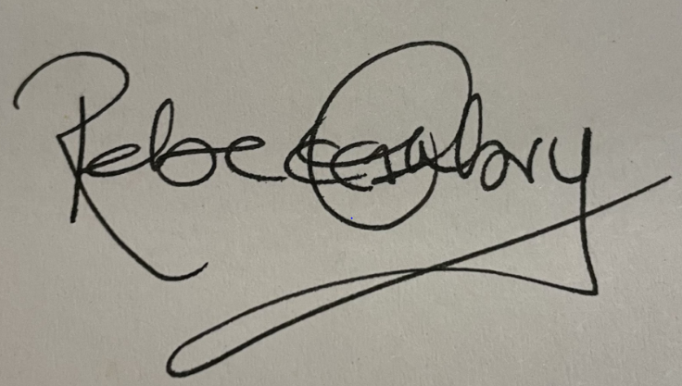

NAME: Rebecca Embry

DATE: 09/02/2025

**Alfriston Parish Council Co-Option Eligibility Form**

1. **In order to be eligible for co-option as an Alfriston Parish Councillor, you must satisfy certain criteria. You must satisfy (a) and (b) below and at least one of the options (c)-(f).**

**Please tick which apply to you:**

1. I am 18 years of age or over: and ■
2. I am a British Citizen or a Citizen of the Commonwealth; and ■
3. I am registered as a local government elector for the Parish; or ■
4. I have, during the whole of the twelve months preceding the date of my co-option occupied, as owner or tenant, land or other premises in the parish: or 🞏
5. My principal or only place of work during those twelve months 🞏

has been in the town.

1. I have during the whole of those twelve months resided in the Parish 🞏

or within 3 miles of it

1. **Please note that under Section 80 of the Local Government Act 1972 a person is disqualified from being a parish councillor if he/she:**

* Is employed by the Parish Council or holds paid office (other than Chairman, Vice-Chairman or Deputy Chairman) under the Parish Council (including joint boards or committees);
* Is employed by an entity controlled by the Parish Council.
* Is the subject of a bankruptcy restrictions order or an interim bankruptcy restrictions order or a debt relief restrictions order or an interim debt relief restrictions order: or
* Has within five years before the date of this co-option, or since his/her co-option been convicted in the UK, Channel Islands or Isle of Man of any offence and has been sentenced to imprisonment (whether suspended or not) for not less than three months without the option of a fine; or
* Is otherwise disqualified under Part III of the Representation of the People Act 1983 (relating to corrupt or illegal electoral practices and offences relating to donations) or the Audit Commission Act 1998.

**Use of Personal Information.**

The Parish Council will use your information, including that which you provide on this application, to assess your suitability to be a Parish Councillor.

**Declaration & Consent.**

I, Rebecca Embry hereby confirm that I am eligible for the vacancy of Alfriston Parish Councillor and I am not disqualified from being a Parish councillor under s80 of the Local Government Act 1972 and that the information given on this form is true and correct.

I confirm that I have read the section entitled ‘Use of Personal Information’ and in signing this form I consent to the use and disclosure of my information included thereon.

SIGNED: 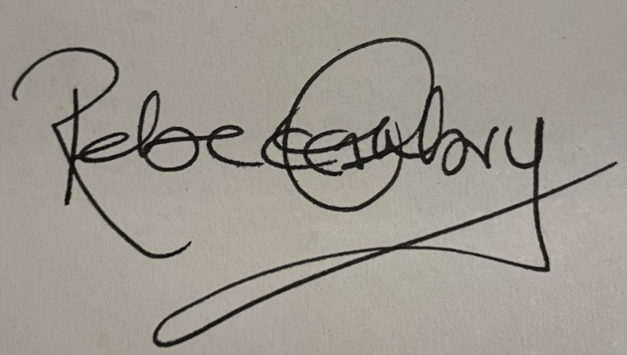

NAME: Rebecca Embry

DATE: 09/02/2025

