ALFRISTON PARISH COUNCIL

www.alfristonparishcouncil.org.uk

CLERK TO THE COUNCIL Alfriston War Memorial Hall

Mrs Suzanna Dry CiLCA Old School House

Tel: 07936 904743 The Tye, Alfriston, BN26 5TL

E-mail: [clerk@alfristonparishcouncil.org.uk](mailto:clerk@alfristonparishcouncil.org.uk) 28th March 2025

**Draft Minutes of a meeting of Alfriston Parish Council (APC), held in the Alfriston War Memorial Hall on Monday 17th March 2025 at 7.15pm**

**__________________________________________________________________________________**

**Present:**

Cllr D Monteath-Wilson (Chair) Cllr A Harris

Cllr S Daw Cllr J Spring

**In attendance:**

Mrs Suzanna Dry – Parish Clerk & RFO

There were approximately 6 members of the public present.

**210. Chairman’s Welcome**

The Chair welcomed everyone to the meeting and wished everyone a happy St. Patrick’s Day.

The Chair advised that Nigel Baelz had withdrawn his application for Councillor which left only one applicant. As a result Agenda Item No. 230 Public Questions would now be held after Agenda Item No. 231 Councillor Vacancy.

**211. Public Questions**

Nick Beechey mentioned the riverbank on the other side of White Bridge is quite a mess after dredging vehicles being on it and asked if APC knew of any plans to improve it. Cllr Harris replied he did not know of any but will make enquiries. Action Point 1.

**212. Apologies for absence**

Apologies were received from Cllr Parkinson and Cllr Watkins.

**213. Update from MP**

James MacCleary’s MP’s report was read out at the meeting and is attached to the minutes (Appendix A). The Clerk confirmed James MacCleary’s office had been in touch wishing to arrange an informal ‘meet and greet’ with James MacCleary in the village. The evening of Tuesday 5th August had been suggested. Cllrs all **AGREED** this date. The Clerk was asked to report this back to James MacCleary’s office. Action Point 2.

**214. Update from Cllr Stephen Shing – East Sussex County Council**

Cllr Shing presented his report to the meeting a copy is attached to the minutes. (Appendix B).

**215. Update from Cllr David Greaves - Wealden District Council**

Cllr Greaves presented his report to the meeting, a copy is attached to the minutes. (Appendix C).

**216. Declaration of interest**

Cllr Daw declared an interest as she is a Church Warden, trustee of Children with Cancer and the Women’s Institute.

**217. Minutes**

Cllr Harris proposed and Cllr Spring seconded a motion that the unadopted minutes of the APC meeting held on 17th February 2025, were a true and accurate record. It was unanimously **RESOLVED** that the Chair duly sign the minutes as an accurate record.

**218. Finance**

To approve the Statement of Finances for March 2025 as attached to the Agenda**.** Cllr Daw proposed & Cllr Harris seconded a motion these be approved. This was unanimously **RESOLVED**. The Clerk will arrange a Qtr4 Finance meeting and Personnel meeting for April. Action Point 3.

**219. Annual Parish Assembly - April 2025**

Cllrs discussed and **AGREED** to hold the Annual Parish Assembly on a separate date to the APC meeting, so that neither meeting was rushed. The date of Monday 14th April at 7.15pm was suggested, Cllrs present were happy with this date and the Clerk was asked to check with Cllr Watkins and Cllr Parkinson before confirming 14th April. Action Point 4. It was **AGREED** that a representative from Wealden District Council and Sussex Police would be invited to speak on decriminalisation of parking and also CityFibre on their planned work in the village. The Clerk was asked to arrange this. Action Point 5.

**220. Coffeehouse Conversations**

The Chair confirmed all portfolios have now had a coffeehouse conversation and suggested they are paused until the Autumn, when they will start again. This was unanimously **AGREED.**

**221. Report on Highways & Twittens – Cllr Vacancy**

CityFibre - As minuted in item no. 219 CityFibre will be invited to speak at the Annual Parish Meeting in April, to discuss project Gigabit. (Details attached to the Agenda).

Willows Car Park - Wealden D.C. have increased the parking charges with effect from 1st April 2025. Details of these have been put on the APC website and sent out via Mailchimp. Copy attached with the minutes (Appendix D). WDC have also advised that there has been vandalism in the car park, specifically targeting the QR code. This has been reported to the Police.

**222. Report on Allotments & Recreation Ground – Cllr Daw.**

Allotments - We have a problem with rubble being used to hold down cardboard on an allotment it is strictly forbidden to use rubble or broken down rubble. The Clerk was asked to send a letter with a copy of the rules and regulations Action Point 6. Spring is in the air at the allotment and some are looking amazing thank you. All renewable notices have now gone out many have renewed we are waiting for a reply from a few. If there is anyone who could make a notice board we would be grateful.  There has been mixed response to the notice advising deposits will be taken from January 2026. Cllr Daw has explained that this is not coming into effect until 2026 and therefore allotment holders have a year’s notice. The Chair mentioned that deposits are common practice in Parish Councils.

Playground  - All is looking good I’m keeping checking for weeds and ivy in front of the new fence, the old sign of no dogs allowed has been repaired and is ready to be put back thank you Arron. I still have not heard back about the Playground Committee or if indeed there is one, if someone could let me know please. Cllr Harris thanked previous Cllrs on APC for helping to get the playground installed, which is a wonderful facility.

Recreation Ground - Cricket season will start soon so not a lot to report the hole from the Rec to the allotments has been refilled as logs keep getting moved, the hawthorn is looking GORGEOUS with its blossom a sure sign spring is on its way.  Cllr Daw mentioned the W.I. would like to hold a car boot sale at the Recreation Ground on Sunday 4th May with funds going to the W.I. Cllrs **AGREED** unanimously to this request, with the usual proviso of public liability insurance and a risk assessment being in place. As APC have no objection Cllr Daw will now check with the Cricket Club.

**223. Report on Public Transport – Cllr Harris**

Cllr Harris read out the following report from Richard Harris of Cuckmere Buses: The Arts Bus has been running all winter on Friday, Saturday, Sunday with an extensive two hourly service between Lewes and Eastbourne , stopping at Charleston Farm House, Alfriston Coach Park and Seven Sisters Country Park.  This service has especially benefited those of us traveling to Lewes, with only a 25 minute journey time in comfortable modern buses and with fully trained and qualified, and friendly volunteer drivers . Can we find a way to promote these valuable services and also the current recruitment drive for new volunteer drivers? As well as the report being in the minutes, It was suggested that Cuckmere Buses place an advert in Cuckmere News.

**224. Report on Environment & Countryside – Cllr Harris reported:**

An interesting period weatherwise since the last meeting in February, particularly when compared with the same period last year. Last night saw the first recordable rainfall for 18 days – and that was only ½ mm.

Since the 17th February, 35mm, less than 1.5 inches, of rain has fallen, compared with 465mm, about 18 inches, for the same period last year. Rain fell on 8 days, compared with 23 days last year.

The average daytime temperatures was 9.15 c, down 1 degree on last year, and the average nighttime temperature 3.4 c, down 1.3 degrees on last year.

So, a very dry period, and consequently there have been no flooding events.

I have received no reports of issues relating to footpaths or rights of way, but have reported a couple of comparatively minor obstructions to East Sussex via their website.

**225. Report on Strategic Planning – Cllr Parkinson**

Cllr Parkinson’s report was attached to the Agenda. The Chair read out the report and asked for any questions, there was none.

**226. Report on Tye – Cllr Spring**

Cllr Spring reported back on the planned Cuckmere Valley sustainable event – there is a meeting being held next week and hoping the date for it will be over the August bank holiday, looking at the Saturday as previously mentioned.

Tye Footpath - salting of the footpaths has not been necessary over the last few weeks. Cllr Spring has been carrying out visual checks when weather dictates.

Water Fountain - Cllr Spring has requested quotes for a new fountain and looking into grants that may assist this. The Chair asked if all Cllrs are happy for Cllr Spring to proceed with this, all **AGREED**. Action Point 7. Cllr Spring is also getting quotes to repair & maintain the current water fountain so that APC can decide if this is feasible. Action Point 8.

Cllr Daw mentioned the concrete bollard at the bottom of the Tye Footpath that has been completely knocked over. Cllr Spring and the Clerk to look into getting this replaced. Action Point 9. Replacement bollard will be wooden as per APC policy on new bollards.

**227. Report from Planning Committee – Cllr Monteath-Wilson (in Cllr Watkins absence).**

272.1 Applications considered by APC Planning Committee since last meeting:

**Ref No: SDNP/25/00973/NMA** – Pyewacket, 19 Deans Rd, Alfriston - No Objection

227.2 Applications notified or awaiting decision from SDNPA

**Ref. No: SDNP/24/04174/HOUS–** Little Winton, Alfriston Rd, Alfriston - Approved

227.3 Enforcement updates from SDNPA - None

Alfriston Court, Sloe Lane - The Chair gave some background on the SDNPA proposal to include Alfriston Court on their Local Plan under sites for ‘possible future development’. No planning applications had been received, it is simply to list this site as a possible site for development in the future. This would be for an extension of the existing building only.

**228. Reports from Outside Bodies**

228.1 Heartstart - Report attached (Appendix E). The Chair thanked Cllr Watkins for organising the defibrillator training. Cllr Spring commented it was a very interesting and informative evening.

228.2 Alfriston Emergency Group - No report.

228.3 Flood Forum - Nothing to report this month.

228.4 Neighbourhood Watch - No report.

228.5 Twinning Committee - Report sent out with the Agenda and read out at the meeting.

228.6 St Andrew’s Church - The music concert on Sunday raised over £2,000.00 for the Church and our thanks go to Katharine Arnold for arranging it. Leaflets are now out for the Music Festival in June.

228.7 Clergy House - Report read out at the meeting and attached (Appendix F).

228.8 Alfriston War Memorial Hall - No report.

228.9 Speedwatch - No report, currently on hold.

228.10 Events -

Sunday 4th May VE Day Celebration, Afternoon Tea on The Tye from 2pm, this has been advertised in the Cuckmere News. Hoping tables will be supplied by AWMH, bring your own chairs and food. Live music from the ‘Land Girls’, games and cakes being sold by the W.I. Funds raised from the cake sales will go to the W.I.

OCC are organising an Easter Eggstravaganza on Saturday 19th April. Posters are displayed around the village.

**229. Correspondence to The Clerk – Asking for permission from the council.**

Wedding Photos on The Glebe – 12th April 2025 - Cllrs **AGREED**, as per appendix F on the agenda.

Wedding Social Space on The Glebe – 27th September 2025 - Cllrs **AGREED** to this request, on the proviso that there is no roping off of the area and no equipment is left out. The Clerk was asked to write to confirm this . Action Point 10.

Wedding A boards - 29th March 2025 - Cllr Spring confirmed the request was for boards outside the AWMH & OCC and not on The Tye itself. Cllrs had no objection to this, but permission would need to be obtained from the AWMH & OCC.

**230. Public Questions**

The Chair closed the meeting at 8.20pm and opened the floor to public questions. The meeting was then re-opened at 8.22pm.

**231. Councillor Vacancy**

231.1 Rebecca Embry gave her introduction to Cllrs.

231.2 It was **RESOLVED** that Agenda Item No. 231 is to be discussed in confidence, and the press and public be excluded in accordance with the provisions of Section 1(2) of the Public Bodies (Admission to Meetings) Act 1960, in view of the business to be discussed.

231.3. To Discuss and Decide on Co-Option of new Councillor. Cllrs retired to the Committee Room for discussion.

231.4. Cllrs unanimously **RESOLVED** to accept Rebecca Embry as a co-opted Councillor and this was announced to the meeting. Cllrs welcomed Rebecca Embry to APC and invited her to join Cllrs at the table where she signed her Declaration of Acceptance of Office, Code of Conduct and Summons Consent.

**232. Date of next meeting –** The next meeting will be held one week later than usual, on Monday 28th April 2025 in the AWMH at 7:15pm. Due to Easter.

The Chair closed the meeting at 8.45pm

Please see Appendices attached below and\or on the website

**Appendix A - MP James MacCleary’s Report**



**Appendix B - Cllr Shing ESCC Report**

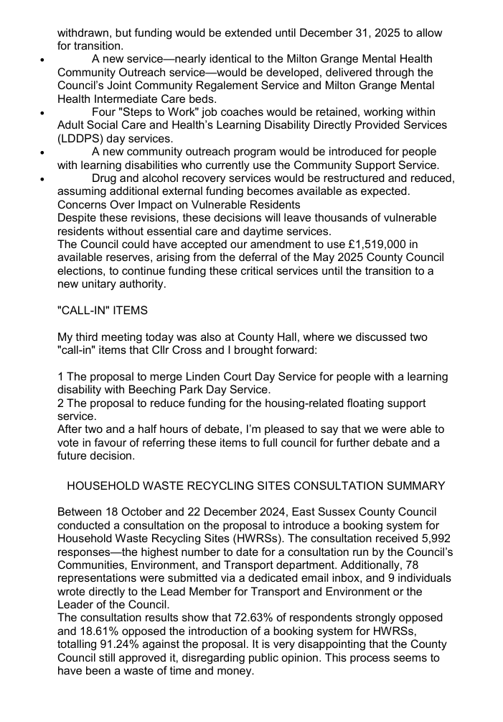

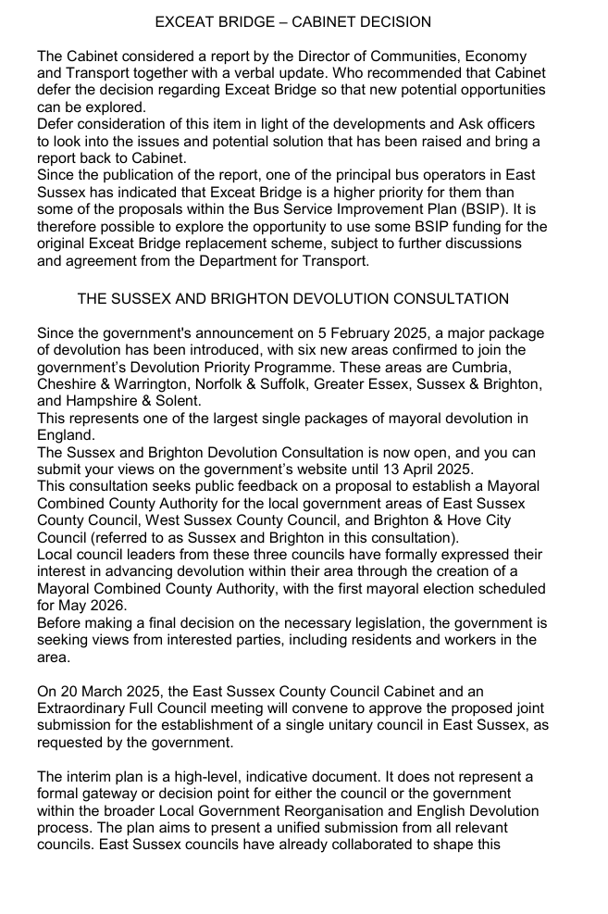

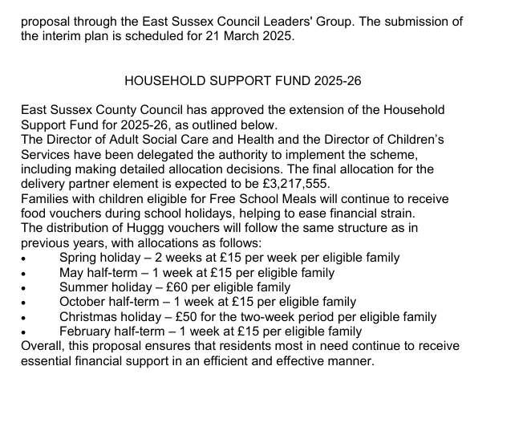

**Appendix C - Cllr Greaves WDC Report**







**Appendix D - Willows Car Park Charges Notice**



**Appendix E - Report from Heartstart – Cllr Watkins**

We held a defibrillator familiarisation and CPR session on 11th March which was attended by over 30 villagers.  This was run together with Eastbourne Area Community First Responders.  They were given practical demonstrations as well as being able to practice themselves the various aspects of basic life support.  It ended with a real life story which showed how important these skills are.  Hopefully they took away with them some useful information should the occasion arise.  Thank you to everyone who attended.  We also now have someone who is interested in becoming a Responder.

**Appendix F - Report from Clergy House**

After a winter of conservation work and a thankfully less flooded time in the garden we will be opening for the new season on Friday 4th April.  We will be open Fridays and Saturdays until the 1st November.  We will be holding many events throughout the year and special openings such as on Easter Sunday.  Thank you."

Holly Jones, Site Manager, National Trust, Alfriston Clergy House, 01323 871961 [nationaltrust.org.uk](http://nationaltrust.org.uk)