

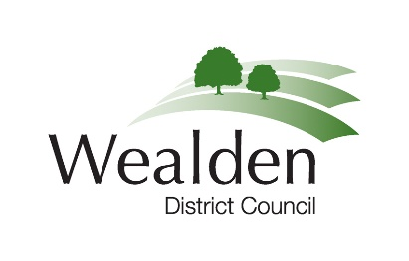
MEDIA RELEASE

018/25 20 February 2025

Council Tax Reduction Scheme bolstered to provide more support for residents

Residents in Wealden are being encouraged to benefit from Wealden District Council’s Council Tax Reduction Scheme.

At yesterday’s Full Council meeting, Wealden District Council’s councillors decided to strengthen the existing scheme by adopting higher income bands. This decision aims to provide more support for low-income households, improve financial stability, encourage employment and align with inflation.

The council has been assisting eligible residents in reducing their Council Tax bills since 2013 and will continue to give its support to the most needed residents of Wealden. The scheme applies discounts to the Council Tax bills of those who qualify for support.

Starting from 1 April 2025, residents will be able to earn more than last year and still receive help with their Council Tax. By raising the income thresholds, more households in Wealden with lower incomes can qualify for higher levels of Council Tax reduction, easing financial pressure on those who need it most.

For example, a single person could receive a 100% reduction in their council tax if their earnings are up to £106.21 a week. A couple with no children could earn up to £156.85 a week, a couple or lone parent with one child could earn up to £219.84, and a couple or lone parent with two or more children could earn up to £281.58.

Council Tax reduction for pensioners is prescribed in law and the council cannot change the scheme for pensioners. The council can however choose the level of assistance it provides to our working age residents through our Council Tax Reduction scheme.

Councillor Daniel Manvell, Alliance for Wealden (Labour Party) and lead councillor for Housing, Benefits and Revenues, said, “This is a great scheme put in place to benefit nearly 4,000 of our working-age residents on lower incomes, supporting them to pay for daily essentials. I want to encourage residents to check if they are eligible, as their Council Tax bill could be reduced by up to 100%.”

Residents can check if they are eligible by following the link below.
Who Can Get Council Tax Reduction - Wealden District Council - Wealden District Council

For further information please contact:
Liane Tew  Head of Digital, Revenue and Benefits  Wealden District Council  Email: Liane.tew@wealden.gov.uk | Or | Sian Killean  Media and Communications officer  Wealden District Council  Tel: 07970 233231  Email: Sian.killean@wealden.gov.uk

