Alfriston Parish Council

Alert System
for Potential Emergency

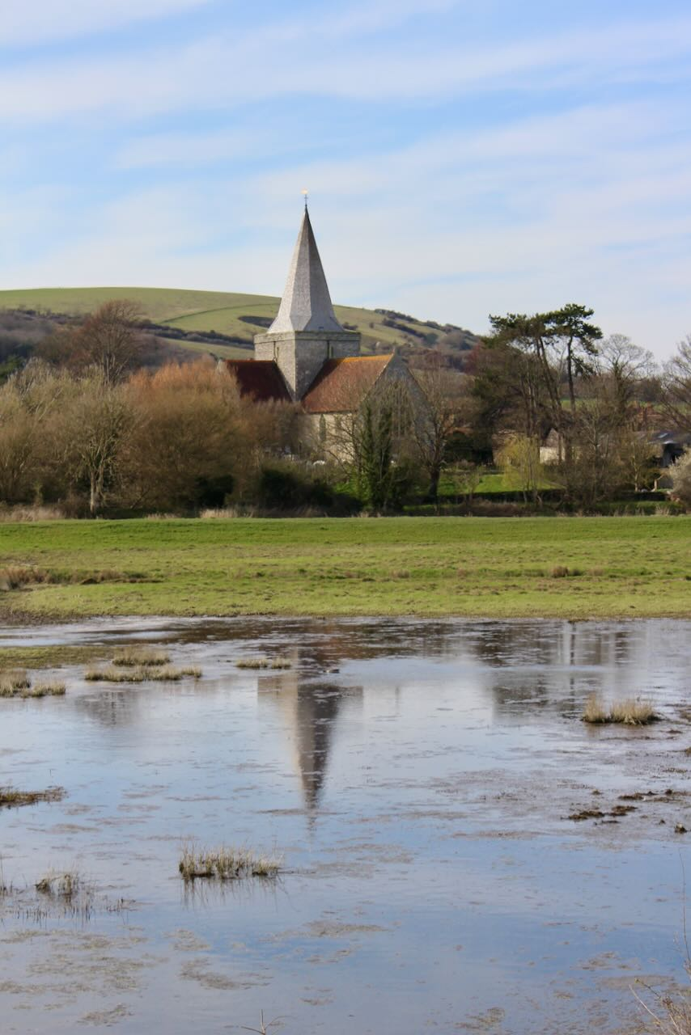

REMEMBER:
If you are in immediate danger:
CALL 999

Distribution List
All APC Councillors, APC Clerk, AEG Leaders, War Memorial Hall, Alfriston Old Chapel Centre, Alfriston School.

PURPOSE
- Alfriston Parish Council is preparing a full Emergency Plan for use in a major event; for example one where the emergency services cannot be contacted or reach the village in a timely manner, where multiple households have to be evacuated, or where there is a threat to life.
- However, most emergencies or warnings of possible danger will not reach the threshold to trigger that plan. This document outlines communications processes for a lower level emergency, for example a flood warning.

PREPAREDNESS
- All APC Councillors and AEG leaders should be signed up to receive flood alerts from EA. https://www.gov.uk/sign-up-for-flood-warnings
- All APC Councillors and AEG leaders should be members of the APC – AEG WhatsApp Group.
- All APC Councillors and AEG leaders should be on the call list for the APC Emergency Phone Group.
- All APC Councillors and AEG leaders should have each other’s mobile numbers.
- All APC Councillors and AEG leaders should retain a copy of this document and the Emergency Plan (when produced). The full plan has many useful contact details which may also assist the response to a lower-level emergency.

ACTIONS
- An actual, or possible, emergency event may include (but is not limited to): a flood warning, other forecast extreme weather, an extended utility outage, or a traffic accident in the locality.

- If an APC or AEG individual becomes aware of an event of increasing concern, they should alert others using the following methods in order of preference:-
- APC – AEG WhatsApp Group (since this offers one to many communication)
- APC Emergency Phone Group (one to one communication)
- Individual mobile phone numbers - text
- Individual mobile phone numbers - voice
- Landline numbers - voice
- Assemble in Market Square
- Further information can also be shared by email, if available.
- The event response will be coordinated by available Councillors. Ongoing decisions need to be made about the response if the event worsens or if the full emergency plan needs to be triggered as detailed in that document.
- Status updates should be shared through the same channels as above.
- An “end of event: all clear” message should be shared through the same channels as above.

