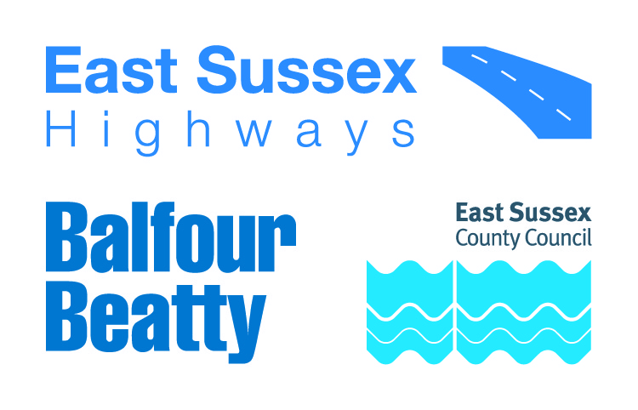

**IMPORTANT ROADWORKS INFORMATION** 2 January 2025

**West Street, Alfriston**

Dear Resident / Business owner,

Balfour Beatty is working in partnership with East Sussex County Council to manage the highways service across East Sussex. As part of this, we will be carrying out drainage works on West Street, Alfriston.

**When do they start?**

Works will be carried out from **Monday 17 February** to **Friday 21 February 2025** between 9am and 4pm.

We will inform you of any changes to the dates or times via advanced warning signs on site.

**What are we doing?**

These works involve replacing damaged underground pipework, root cutting and road marking refreshments.

**How will this impact highway users?**

The team will be working from the junction of Waterloo Square to the entrance of Sloe Car Park.

Access will be restricted for residents for the duration of these works.

Traffic will be diverted via West Street, North Road, The Broadway, Deans Road, Weavers Lane, High Street and vice versa.

If you need vehicle access to your property, please discuss this with the team onsite. Please bear in mind there will be delays whilst the area is made safe and your vehicle is escorted by site marshals. Access for emergency vehicles will be maintained at all times.

**Information for residents and businesses**

**Parking:** If required, we will put out ‘no parking’ signs and cones on the site to advise where parking is restricted. Please avoid parking in these locations as it will delay our works.

**Weather:** All of these works are subject to favourable weather conditions, for example heavy rain may affect the progress of the works.

**Waste collection:** Access will be granted for any waste collection.

Properties close to the carriageway may experience a temporary disturbance as this can be a noisy process and those properties may experience flashing lights and reversing sirens.

We would like to take this opportunity to apologise in advance for any inconvenience or disruption this work may cause, however this forms part of our continuing improvement for the East Sussex highway network. Should you have any concerns regarding these works, you can contact us at eshcomms@balfourbeatty.com.

For information on roadworks and journey planning, visit www.[One.Network](https://one.network/).com. Please follow us on X (formerly Twitter) [@esccroads](https://twitter.com/esccroads) or Facebook [@EastSussexHighways](https://www.facebook.com/EastSussexHighways/) for updates. If you would like to know more about East Sussex Highways and what we do, please visit our website www.eastsussexhighways.com.

Thank you,

**East Sussex Highways**

**Report a problem here: Leave feedback on these works here:**

**Map of works area and diversion route**

****SH/MS