Emergency - Temporary Road Closure - U7726 - Winton Street, Alfriston - 14/05/2024 to 17/05/2024

Please be aware that the following works will be carried out:-

U7726 Winton Street, Alfriston
Emergency Temporary Road Closure | From the junction with the C39 North Street to the junction with the U7726 West Street, a distance of approximately 90 meters.
14th May 2024 to 17th May 2024 | works anticipated to take 4 Days to complete.
To allow South East Water to carry out emergency repair works.

Diversion via: C39 North Street – U7726 Waterloo Square – U7726 West Street and Vice Versa
Advance warning signs will be placed on site advising of actual date of works
If you need to discuss this further please contact:

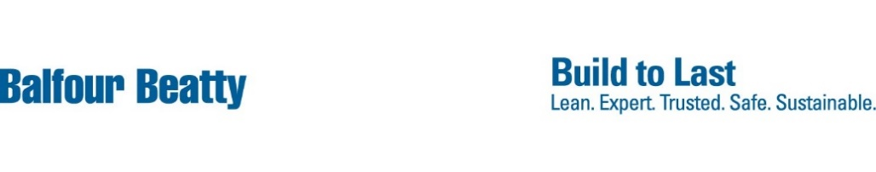
South East Water on 03330000365

