ALFRISTON PARISH COUNCIL

**CLERK TO THE COUNCIL** Alfriston War Memorial Hall,

Mrs Suzanna Dry Old School House, The Tye,

Alfriston,East Sussex, BN26 5TL

Telephone – 07936 904 743

Email – clerk@alfristonparishcouncil.org.uk

Monday 13th May 2024

All members of the Parish Council are summoned to a meeting of Alfriston Parish Council to be held in the Alfriston War Memorial Hall on **Monday 20th May 2024. This meeting will follow the Annual General Meeting which commences at 19:15.**

*Please note that a digital sound recording is made of all meetings of Alfriston Parish Council including Public Questions sessions. The recording is not for publication and is only used to aid accurate minute taking.*

S.C. Dry

Mrs Suzanna Dry - Clerk to the Council

**16. Chairman’s Welcome**

**17. Public Questions**

**18. Apologies for absence**

**19. Update from Maria Caulfield MP (Appendix A)**

**20. Update from Cllr Stephen Shing – East Sussex County Council**

**21. Update from Cllr David Greaves - Wealden District Council**

**22. Declaration of interest**

**23. Minutes**

To agree as a true record the minutes of the APC meeting and Annual Parish Assembly, held on 22nd April 2024 .

**24. Finance**

To approve the Statement of Finances for May 2024. **(Appendix B)**

**25. D Day Celebrations Update - Cllr Daw**

**26. Report on Highways & Twittens – Cllr Rabagliati**

- Parking on the Furlong.

**27. Report on Allotments & Recreation Ground – Cllr Daw**

- Cost of Allotments and pricing

**28. Report on Public Transport – Cllr Harris**

**29. Report on Rights of Way and Countryside – Cllr Harris**

**30. Report on Strategic Planning – Cllr Spring**

**31. Report on Tye – Cllr Parkinson (Appendix C)**

**32. Report from Planning Committee – Cllr Watkins**

32.1 Applications considered by APC Planning Committee since last meeting

**SDNP/24/01398/FUL** Deans Place Hotel, Whiteway, Alfriston, BN26 5TW – No objection

**SDNP/24/01399/LIS** - Deans Place Hotel, Whiteway, Alfriston, BN26 5TW - No objection

**SDNP/24/01400/FUL** - Deans Place Hotel, Whiteway, Alfriston, BN26 5TW - No objection

**SDNP/24/01400/FUL & LIS** - Deans Place, Whiteway, Alfriston, BN26 5TW – No objection

**SDNP/24/01341/LIS** - Deans Place Hotel, Whiteway, Alfriston, BN26 5TW - No objection

**SDNP/24/01342/**LIS - Deans Place Hotel, Whiteway, Alfriston, BN26 5TW - No objection

**SDNP/24/01338/DCOND** - SDW, France Hill Kings Ride, Alfriston,BN26 5XW - No objection

**SDNP/24/01643/TPO** - 16 Kings Ride, Alfriston, BN26 5XP - No Comment

**SDNP/24/01565/HOUS** - Riverbank, River Lane, Alfriston, BN26 5SX - No objection

I**SDNP/24/01636/LS** - Old Manse Flat, High St, Alfriston, BN26 5SZ - Application Removed

**SDNP/24/01673/DCOND** - Flint Cottage, 12 North St, BN26 5UG - Comments not permitted

**SDNP/24/01675/DCOND** - 11 North St, Alfriston, BN26 5TW - Comments not permitted

32.2 Applications notified or awaiting decision from SDNPA

None

32.3 Enforcement updates -

**SDNP/24/00166/BRECON** - 6 Kings Ride, Alfriston, BN26 5XP - No update from SDNP.

**33. Reports from Outside Bodies**

33.1 Heartstart

33.2 Alfriston Emergency Group

33.3 Flood Forum

33.4 Neighbourhood Watch

33.5 Twinning Committee **(Appendix D)**

33.6 St Andrew’s Church

33.7 Clergy House

33.8 Cuckmere Buses

33.9 Alfriston War Memorial Hall

33.10 Speedwatch

33.11 Events

**34. Correspondence to The Clerk – Asking for permission from the council.**

**35. Public Questions**

**36. Date of next meeting -** Monday 17th June 2024 in the AWMH at 19:15.

Appendix A

Update for Alfriston Parish Council

May 2024

Please accept my apologies that I am unable to join you at your upcoming meeting. I do however have the following updates for the parish.

Government Funding for Roads

I welcome East Sussex County Council's plan for utilising the initial £52 million government funding to resurface local roads. This funding, sourced from savings due to the cancellation of Phase 2 of the HS2 project, underscores the government's commitment to improving transportation networks. With £5.9 million allocated for pothole repairs and a projected increase in road investment from £34,650,000 to £56,496,000, there's a clear dedication to enhancing road infrastructure. Overall, these efforts signify a promising step toward visibly better roads in our community.

Lewes Delivery Office Update

I've been continuing to liaise with Royal Mail and the Minister responsible for Postal Services regarding service levels in Lewes and surrounding villages. The Universal Postal Obligation, set by Ofcom under the Postal Services Act, remains unchanged since 2011, with no plans for alteration by the government. Royal Mail is obligated to meet delivery standards set by Ofcom, with the regulator having enforcement powers. I have been informed that recent disruptions in mail deliveries in Lewes were due to high sickness rates and vacancies among staff, but the situation has improved with new hires and reduced sickness levels. David Gold, Director of External Affairs and Policy for Royal Mail, visited the Lewes Delivery Office unannounced to assess performance and address challenges. Recruitment efforts are underway to further improve service. I'll continue monitoring closely and provide updates as needed. Thanks to our local posties for their hard work, and feel free to reach out if  any residents are concerned over their deliveries or if further assistance is required.

Waspi Update

The WASPI Campaign seeks justice for women affected by changes in the state pension age, advocating for those born between April 6, 1950, and April 5, 1960. Since 1995, when the government announced equalising the pension age, concerns have arisen regarding the lack of adequate notice and information provided. As an MP since 2015, I've supported the campaign, submitting one of the initial test cases. Recently, the Parliamentary and Health Service Ombudsman ruled that the Department for Work and Pensions failed to provide sufficient information, recommending a compensation scheme with payments ranging from £1,000 to £2,950. While constituents welcome the acknowledgment of the need for compensation, there are concerns about the proposed levels. I've been urging ministerial colleagues for a swift establishment of the scheme. Your input on this matter would be valuable and can be shared with me at [maria.caulfield.mp@parliament.uk](mailto:maria.caulfield.mp@parliament.uk).

Renter’s Reform Bill Progressing

In the ongoing progress of the Renters Reform Bill, significant amendments have been introduced during Commons Committee and Report Stages. The Government has proposed measures to introduce a Decent Homes standard in the private rented sector, create a new ground for possession allowing landlords renting to students to seek possession before each new academic year, and prohibit discrimination against potential tenants based on benefits status or having children. Additionally, amendments have been tabled to establish a six-month period for tenants between tenancies, preventing short-term lets, and requiring an assessment on barriers to possession before abolishing Section 21 for existing tenancies.

Best Wishes

Maria Caul

Appendix B

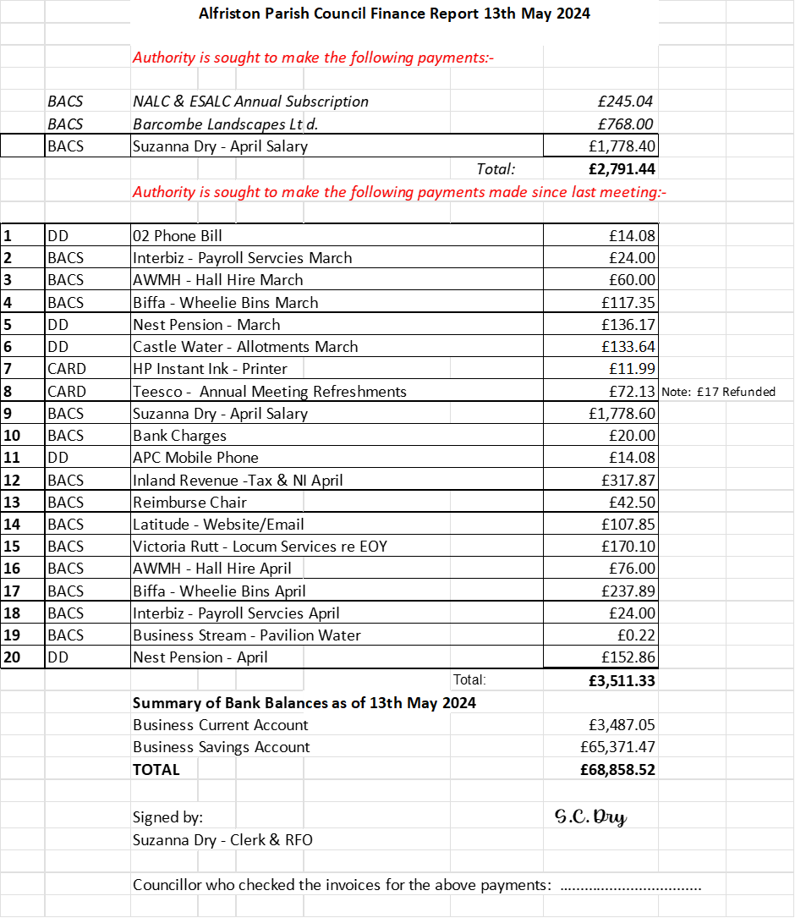

Appendix C

## The Tye Portfolio: Monthly Update May 2024. Neil Parkinson.

The Tye

#### General Maintenance

* The damaged drain cover near the WMH remained an issue, the last time I was able to inspect it. We have agreed to reshape the ground in this area and AEG are sourcing a new cover.
* The Tye Team have planted new flowers in the Village Garden area. The stinking iris has been removed from the Clergy end of the Tye.

### The Tye Road

1. **Road edge of Main Section**

* We have agreed that Hailsham Roadways will carry out this work.
* We are awaiting final SDNPA approval and confirmation of some buried services.
* We need to set a date for the work and create a project plan to facilitate it.
* It is critical that the work is carried out to the original pricing of £23,306 – the proposal was valid for 30 days – any significant increase would make it unaffordable.

1. **Double Yellow Lines at the Turning Circle Section**

* Huge thanks to everyone who came to apply the Plastic Paint to refresh the very faded yellow lines.
* The materials were expected to be sufficient for the whole turning circle but only lined about a third of it. There was significant wastage in mixing and the surface was hard to cover. Additionally, the material was difficult and unpleasant to use. I would prefer a “cleaner” application method.
* I therefore propose to obtain thermoplastic lining for the remaining sections, as an experiment to see if this is easier to apply.
* The cost of this, from MeonUK, is expected to be £172 inc shipping (in comparison to £152 for two more cans of plastic paint). This will drop to £150 if I can collect on May 23rd, avoiding shipping costs. To be taken from the Tye Road reserve budget. **Councillors are asked to approve this.**

1. **Potholes**

* APC has already agreed a DIY approach to pothole repair, with the assistance of villagers and local businesses, including the Wingrove.
* I have measured the potholes, developed a materials list and taken advice from those with previous experience, but there are some variables in how much will be required and what asphalt will be best to use. I believe the cost of materials to repair all the potholes would be £1k (or less); this cost primarily driven by the cost of replacement asphalt. Learning the lesson of the yellow lines, my intention is to spend up to this amount from the Tye Road reserve budget, and see how far the materials go, approaching the spend and repair incrementally. **Councillors are asked to approve this approach.**
* I have again spoken to the Wingrove, who are, kindly: willing to fund up to £500 for materials; may be able to access low cost bonded Type 1 Sub Base; and can contribute to the working party. My thanks to them. *If other businesses or villages can help with materials or labour, I would be grateful if they would contact the Clerk.*
* If APC buy a bulk bag of Type 1 Sub Base we will have a substantial quantity left for future repairs but will need to store it near the Tye Road. I assume this would need to be in the area behind the Tye Road alongside the Clergy House, or behind the two parking spaces opposite the Wingrove Car Park. Other suggestions are welcome. **Councillors are asked to approve this.**
* My aim continues to be to get this pothole work completed as soon as is practicable, starting with the holes that are most impactful. These are the ones by the Wingrove, beside the Gallery passage, and just before the turning circle.
* I want to order the materials ASAP. Dates for the work will then need to be agreed with all those who have volunteered to help.

Appendix D

Alfriston and Cuckmere Valley Twinning Association

The Big Fat Quiz was great fun and well attended. The excellent selection of varied questions gave everyone their chance for a "lightbulb moment". Scores were close throughout the evening, and the neck-and-neck performance of two of the teams ended the evening with a draw. Association funds were swelled by customers of the bar and the raffle.

The next event is the big one: the official visit of our guests from Veules-les-Roses. Some of them are new to their group, so we will be meeting new guests as well as seeing friends. We look forward to this, and are sure they will enjoy the programme of activities we have arranged. Fingers crossed for good weather!

We have members in a wide area of the Cuckmere Valley, Alfriston and Seaford.

New members are always welcome, and there is no need to speak French, or to have a huge house!

By Wendy Little