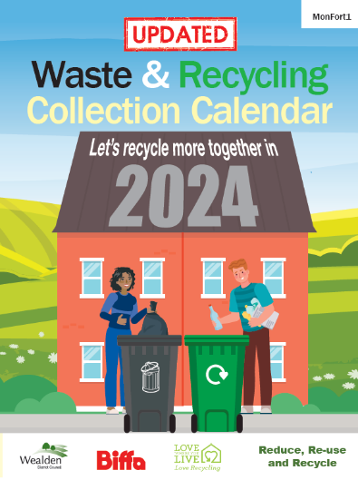
Changes to Rubbish and Recycling Collection Days

Rubbish and recycling collections are changing for around 85% of properties in Wealden from Monday 15th April 2024.

Letters and calendars are being sent out in the next few days so please look out for this important information on your rubbish and recycling collections.

Some properties will not have a day change but will have a change in the pattern of their collections so it is very important that you check the letter carefully as it details which bin needs to be put out on which day.

Please ensure all bins are presented at the boundary of your property by 7am on collection day as there may also be a change in the time your bins are collected

Please note that the changes are only on the refuse and recycling collections. Garden waste collection will remain on the current collection schedule and will continue as before.

For further information visit www.wealden.gov.uk/collection-schedule-changes

Need a handy reminder as to which bin gets collected when?

Sign up to Wealden Weekly and get an email every week about your collections, visit: www.wealden.gov.uk/wealden-weekly

