**ALFRISTON SPEEDWATCH GROUP**

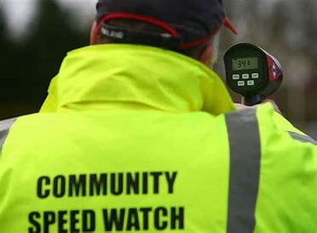

**VOLUNTEERS NEEDED!!**

Alfriston Parish Council have set up a Speedwatch Group and we are currently running with 5 members. To ensure we do not burn out the existing volunteers, but continue to have regular sessions, we need further volunteers please!

You will need to undertake a short e-learning package online and short face to face training with the Clerk but then you would be good to start. If we have more members, it would likely to be one session a month.

If you are interested in joining please can you contact the Clerk on [clerk@alfristonparishcouncil.org.uk](mailto:clerk@alfristonparishcouncil.org.uk)

Thank you

Mrs Victoria Rutt

Clerk and RFO to APC